Full Inventory Process Overview

(Original Workflow)

New Asset Step 1 - Preparation
- Create a new folder inside the Asset folder and name it [(Quarter) (Year) Refresh] (e.g. Winter 2020 Refresh)
*Every document that will be created for this refresh should be put in this folder
- Make a copy of the Snipe-IT template “importassets-template.csv” in the Templates folder
- Rename the .csv in (Quarter)(Year)-importassets.csv format (e.g. wi20-importassets.csv)
- Put the newly created ##-importassets.csv into the refresh folder created in step 1

New Asset Step 2 - Importing into Snipe IT
In this step, we gather and import data into Snipe-IT, our asset management platform,
1. Place a new asset tag on the new computer
2. Scan that asset tag and its respective serial number for that computer into ##-importasset.csv. Repeat until all new computers are recorded.
3. Fill out other columns in that .csv
4. Import .csv into Snipe-IT
- This is an automatic process for the Create New > Asset
- Snipe-IT will automatically create new categories for each attribute (e.g. model, locations, model id etc.) if they do not already exist in the database. It is important to check the spelling/naming and whether that category already exists in Snipe-IT to prevent duplicate/misspelt categories from being created.
- If things aren't importing right, check out the Snipe-IT caution/troubleshooting guide

New Asset Step 3 - Add assets into Apple's Apple School Manager (DEP)
This step for Mac's should be done by a System person who has access to Apple School Manager, preferably Ashlar.
1. There are 3 ways to select new devices in DEP:
- Adding new assets with an order number (most preferred)
- Adding new assets by the list of serial numbers: copying serial numbers from the ##-importassets.csv created in previous steps and paste to the box
- Adding new assets via CSV: copy the serial numbers from the ##-importassets.csv and paste into column A of a copy of the dep-template.csv in the Templates folder
2. Under tab "Device Assignments," perform action “Assign to Server,” either to Learning-Technologies, STLP, or Learning-Technologies-Dev.

Replacing Assets Step 1 - Preparation Process

Overview | In this first step of the process of replacing assets, we get our files and computers ready to make changes.
Input | - replacingassets-tracker-template.csv  - Data about current assets from Snipe-IT  - Data about new assets from this quarter's importasset.csv (output of the "new asset" procedure)  - A group of new computers in stock
Output | - A completed ##-replacingassets-tracker spreadsheet filled with information about pulling off and going into computers  - Computers with an assigned seat name
Next steps | Step 2- Swapping assets

1. Make a copy of replacingassets-tracker-template.csv in the Templates folder
2. Move the copy to the Refresh folder created in previous steps and rename it to (quarter)(year)-replacingassets-tracker.csv. (e.g. wi20-replacingassets-tracker.csv)
In the template, there are 2 tabs: (1) Pulling Off and (2) Going Onto.
3. In the "Pulling Off" tab, fill out the information about computers pulling off the floor (being replaced) by exporting from Snipe-IT
- On the sidebar at the bottom "Reports > Custom Asset Report"
- Check the following boxes for the categories to export: Asset Tag, Asset Name, Asset Models, Serial
- Type in 'Location' on the right side if applicable (i.e. if we're replacing section OUGL-2-N, Snipe-IT will only grab the information from computers in section OUGL-2-N)
4. In the “Going Onto” tab, fill out the information about computers going onto the floor from the ##-importassets.csv list in your Refresh folder.
5. Assign new computers with a corresponding seat (example, OUGL-2-NE-A01-M) on the floor based on the “going onto” tab.
6. Put a post-it note on each computer with its corresponding seat name assigned in the step above.

Replacing Assets Step 2 - Swapping Assets

Overview | This 2nd step happens once we start physically swapping the assets.
Input | - ##-replacingassets-tracker filled with information (output of step 1)
Output | - Updated ##-replacingassets-tracker  - Replaced Mac computers removed from Jamf
Next steps | Step 3 - Update records

1. When ready to remove computers from the floor, for Mac's, delete the computer accounts in Jamf.
2. When pulling computers off the floor, mark Y on column to "Removed?" on the "pulling off" tab to keep a record of what’s been removed
3. When putting computers on the floor, mark Y on column to "Placed?" on the "going onto" tab to keep a record of what new computers have been replaced

Replacing Assets Step 3 - Update Records

Overview | In this final step of replacing assets, we update changes to our systems.
Input | - ##-replacingassets-tracker.csv (output of step 1 & 2)  - shelfstatus-import-template  - surplusstatus-import-template
Output | - ##-surplusstatus-import  - ##-shelfstatus-import  - Updated status in Snipe-IT  - Surplus Mac computers being removed from Apple School Manager
Next steps | Surplus process when applicable
- Deleting the assets in Device_Info.csv spreadsheet in lill-dir/jamf/package
- On the replacingassets-tracker "pulling-off" tab, fill out whether a computer is going to surplus or staying on our shelf (consult with the Manager)
- Update asset status in Snipe-IT:
  - For surplus ones
    - Duplicate the surplusstatus-import-template, move to this quarter folder, and rename it to include the quarter, <quarter><year>-surplusstatus-import
    - Filter out "surplus" ones
    - Copy Asset Tag and Serial No. information of these computers from the tracker and paste to ##-surplusstatus-import. All other fields should be the same as the example row.
    - Import into Snipe-IT to update all the assets we replaced to a "need to surplus" status. Make sure to check "updating existing values"
  - For those being kept
    - Duplicate the shelfstatus-import-template, move to this quarter folder, and rename it to include the quarter, <quarter><year>-shelfstatus-import
    - Filter out "shelf" ones
    - Copy Asset Tag and Serial No. information of these computers from the tracker and paste to the ##-shelfstatus-import. All other fields should be the same as the example row.
    - Import into Snipe-IT to update the asset status to "Ready to Deploy." Make sure to check "updating existing values"

Surplus Step 1 - Preparation process

Overview | This is the second article in the series to read for our Surplus process. In this first step of the process, we get the physical assets and spreadsheets ready for our surplus.
Input | - This quarter's replacingassets-tracker.csv (output of the Replacing Asset process)  - Department Surplus Template
Output | - Wiped surplus assets sitting in a group in the inventory  - The Surplus Tracker filled with the surplus assets information
Next steps | Step 2- Surplus Request Recording
- For Mac's, unassign the asset from Apple School Manager (DEP). Should consult with the Manager. This step MUST be completed before wiping the Mac's
- Wipe all surplus computers (remove firmware passwords, etc.)
- Physically make sure all surplus assets are separated from other assets
- Duplicate the Department Surplus Template for your period
- Copy information of surplus computers from this quarter's replacingassets-tracker.csv and paste to the Surplus Tracker column A to D*:
  - Asset tag
  - Serial Numbers
  - Model
  - Model Name
* Update the fields on the surplus tracker to match with the information that surplus asset types have. Only one type of asset (example, iMacs) is allowed per worksheet tab. If there is more than one type, duplicate new tabs in the same workbook. An example can be found from the Winter 2020 Department Surplus Tracker. There was one tab for iMacs surplus and one for switches because switches have different fields.

Surplus Step 2 - Request Recording process
KB0029521 - Latest Version
Knowledge base: Learning Technologies
25 views

Overview | This is the third KB in the series to read for our Surplus process. In this second step of the process, we record new requests for the surplus assets from our IT support email.
Input | The spreadsheet completed with all surplus asset information from step 1, preparation
Output | The input spreadsheet is completed with asset requests
Next steps | KB Surplus Step 3 - Assigning

- Check with Ashlar to see if there are any pre-reserved assets. Record them in:
  - Column G: Full name of the requestors
  - Column H: The number of assets requested in their email
- Report the “Available” number of assets on the spreadsheet to Ashlar. This is how many assets we still have available after taking into account all the reserved ones. Ashlar will send out an offer email to the campus. Different departments will start requesting.
- Record new requests to the spreadsheet upon receipt
- Give this task the highest priority so you can report to Ashlar at the end of your shift, or upon his request, the accurate number of unclaimed surplus assets

Surplus Step 3 - Asset Assignment Process
KB0029524 - Latest Version (Draft)
Knowledge base: Learning Technologies
21 views
Overview | This is the fourth KB in the series to read for our Surplus process. In this third step of the process, we record assign surplus assets to their future owners.
Input | The spreadsheet completed with all surplus asset information and asset requests
Output | Some or all assets are assigned their new owners on the spreadsheet  Assets in the inventory have sticky notes with their owners' name sitting in a group
Next steps | KB Surplus Step 4 - 1024 Transfer Form

- Write the requestor’s name on to a sticky note and stick them to a surplus asset
- Enter the name of the respective requestor to column E (Target Person) for that asset (recommend copy their full name from column G and paste to avoid typos and ensure proper formula calculation)
- Continue the above steps until that requestor gets assigned their sufficient number of assets as requested. All assets assigned for one person must physically sit next to each other in a row or so. If you properly assign the number of assets for the requestor and properly record their name, column J “Need to assign more” should reflect “None”.
- Enter the asset's location to column M to make it easier to identify and move the assets later
- Highlight and turn on protection for the asset range, column A-E. This creates a warning when this range is edited to prevent unintentional changes
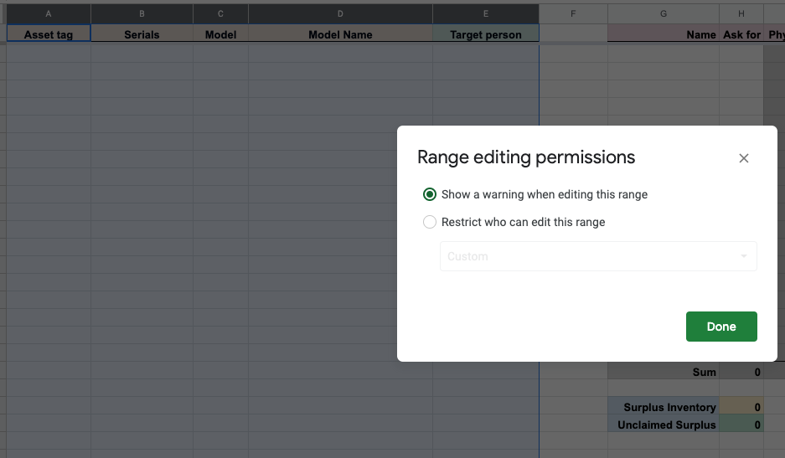

Surplus Step 4 - 1024 Transfer Form
KB0029525 - Latest Version
Knowledge base: Learning Technologies
22 views

Overview | This is the fifth KB in the series to read for our Surplus process. In this fourth step of the process, we complete the paperwork for transferring the surplus assets, aka 1024 Form, for the requestor.
Input | Surplus asset assigned to their new owners physically and on the spreadsheet
Output | Signed 1024 transfer forms
Next steps | KB Surplus Step 5 - Pick up

- Duplicate the 1024 template in the Google Drive to this quarter surplus shared folder
- Rename file with the requestor name and quarter
- Record on the form all information from the email and the spreadsheet. Follow up with Ash or the requestor if need more information
- Let Ash know once you complete the form so he can review and ask Jake to sign when it's appropriate
- After 1024 is signed and Ash, or a member of Systems Team, have notified the requester of their status, column K and column L are updated to “Signed” and “y” respectively
- Make a copy to tape on the asset that goes to the new owner. The original goes to Ash for filing
- Scan, upload, and rename to match the forms to Transfer folder in the Shared Drive
- Update status in column N to Pending Confirmation
- Highlight and turn on protection for the request range, column G-Q. This creates a warning when this range is edited to prevent unintentional changes.

**In the event of the surplus asset owner change at this stage, still keep their form in the folder but add "-CANCELLED" to the form name. Update the spreadsheet to reflect this change and re-assign the assets to another owner.**

Surplus Step 5 - Pick up process
KB0029526 - Latest Version
Knowledge base: Learning Technologies
19 views
Overview | This is the sixth KB in the series to read for our Surplus process. In this fifth step of the process, we arrange pick up and complete the transfer process to new owners.
Input | Signed 1024 form and assets assigned for new owners
Output | Assets transferred from our hand to the new owner.
Next steps | Surplus 2.6 - Update in Snipe-IT process

- Once date and time for pick up is confirmed, record them in column O and P. Update status in column N to "Confirmed"
- Bring assets that are scheduled to pick up in the most recent date to 230. Update status in column N to “Staged in 230”
- Update status in column N to “Y” once they are picked up
- Utilize the filter to sort out assets that have been picked up for easier administration

Surplus Step 6 - Update in Snipe-IT process

Overview | This is the seventh KB in the series to read for our Surplus process. In this sixth step of the process, we update the status of the surplus assets to Snipe-IT, our asset administration system.
Input | Completed transfer and record of surplus assets
Output | All surplus asset status changed to "Archived" on Snipe-IT
Next steps | KB Step 7, emailing EIO.

Two ways
1. Change in Snipe-IT (recommended - use when the assets can be identified in a group, such as locations or asset models)
1. Go to List All to see all the assets
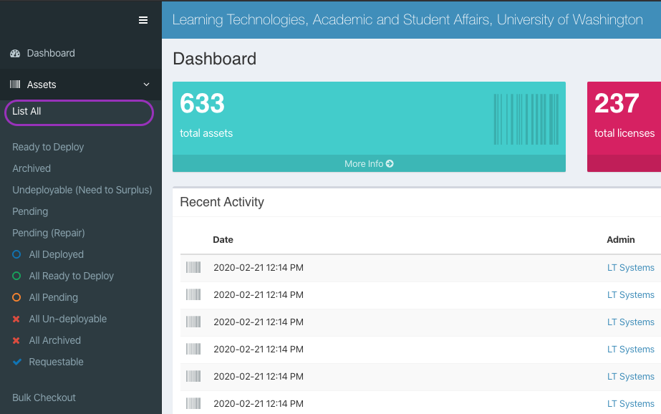
2. Search to filter out the group that get surplused (1). Then check all or some from the list (2). Click "Go" to edit them (3).
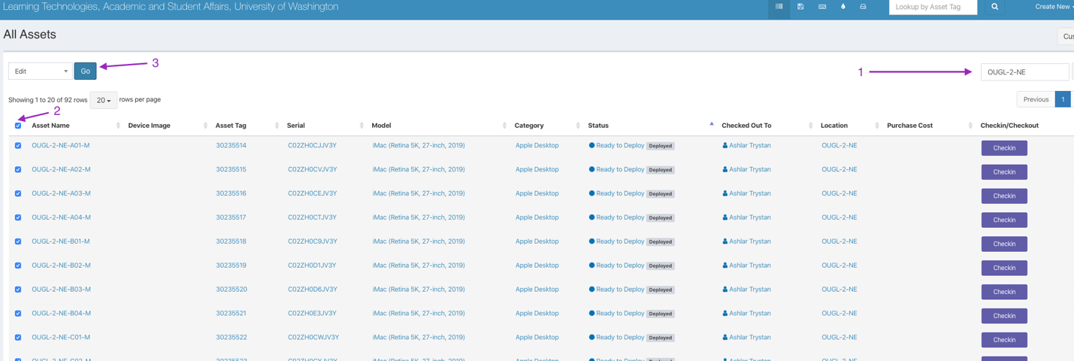
3. Confirm the number of assets being changes, change the status to "Archived" and "Save" changes
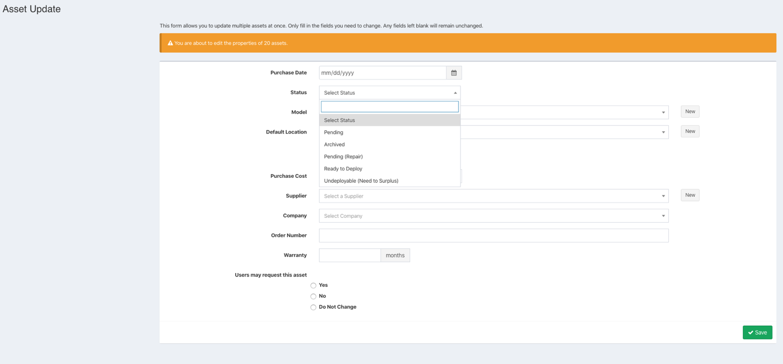
2. Change by importing
1. Duplicate the Status_Import_SnipeIT_Template in the Drive to this quarter surplus folder
2. Enter all surplus assets to each column based on the asset record. Look into Snipe-IT system to make sure you use the correct existing record for the asset without creating new ones.
3. Update the field "Status" to "Archived"
4. Import to Snipe-IT

Surplus step 7 - Email 1024 records to EIO

Overview | This is the eighth KB in the series to read for our Surplus process. In this seventh step of the process, we complete the process with 1024 forms being emailed to the EIO office.
Input | All surplus assets are picked up.  1024 forms are posted to the Drive and a copy is filed in Ashlar's office
Next steps | Double check the Surplus Overview process. If so, congratulations, you have completed the surplus process!
Email all completed 1024 forms to Equipment Information Office (EIO) at eio@uw.edu

